7838 Wilkerson Court
San Diego, CA 92130
NaruwanTaiko@gmail.com
Court of Lati, Asano Taiko U.S.
Southern California
Progressive Taiko  aka Prota,  Challenger,  vs.  Naruwan Taiko  AKA LEAGUE OF CHAMPIONS | Response to PROgressive  Taiko’S MATSURI CHALLENGE  LETTER

NARUWAN TAIKO (“Naruwan”) respectfully laughs and formally ACCEPTS Prota’s Matsuri Challenge designated for January 25, 2014.
- FORMAT
SINGLES
Diana Wu vs. Masa Miyano, 5
Devin Kenzo Tani vs. Tomomi Hongo, 405
Random Naruwan Girl vs. Random Kyodo Girl 5

DOUBLES
Jennifer Sim and Ryley Duong
vs. Kelvin Lee and Samantha Ho, 110

Jimmy Nguyen and Jordan Tani
vs. Michael Hirota and Dan Porter, 405

- STAKES
Should Naruwan win this glorious battle, we request that Prota come visit us in San Diego this year and give us a mini-concert!

- HAIKUS
In contrast to your wordy, lengthy, sleep-inducing letter, Naruwan decided to provide each challenger their very own haiku.

To: MASA
Hello Miyano
Nice Muscles. Too Bad They’re Fake. 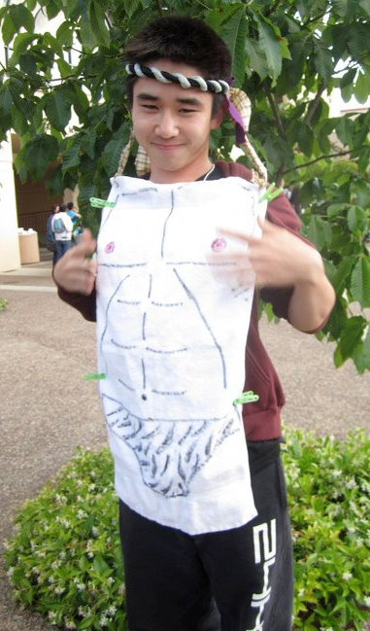
Look Here. Be AFRAID. 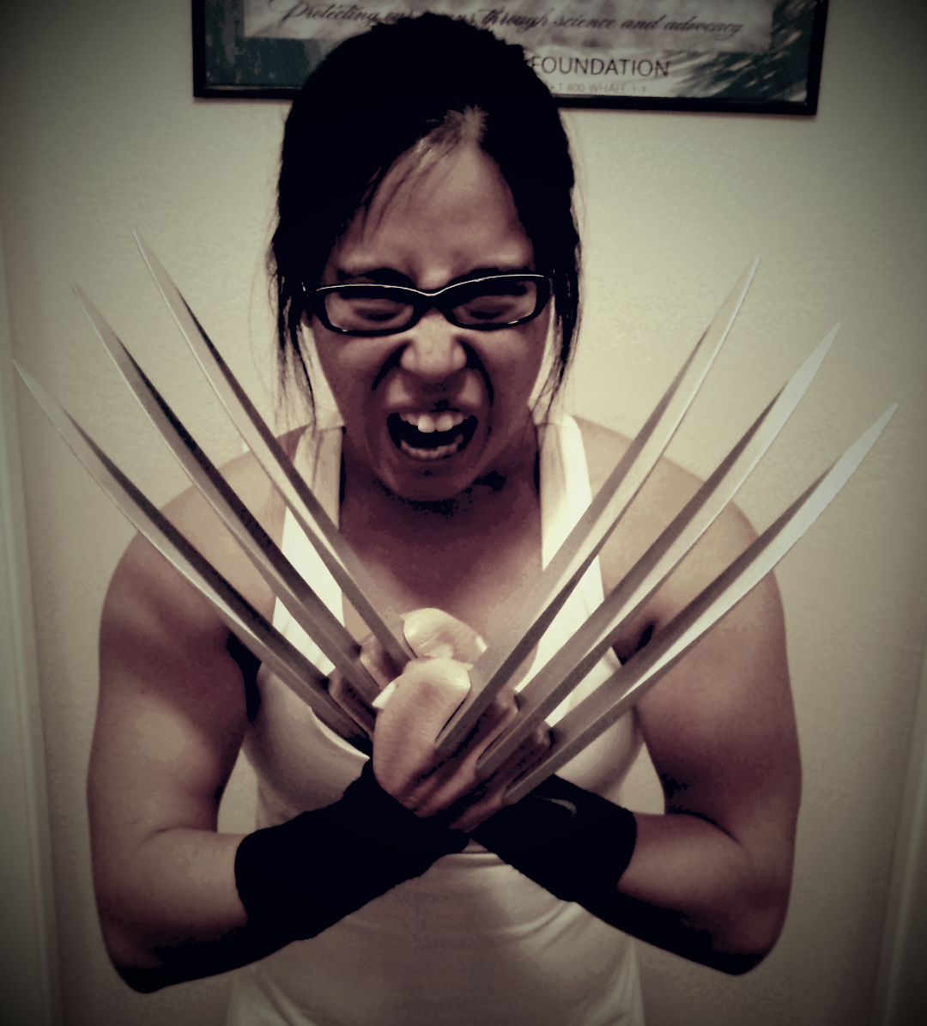

Start working out,
Diana

To: TOMOMI
Tomomi Hongo
How Is The Weather Down There
Diaper Needs Changing? 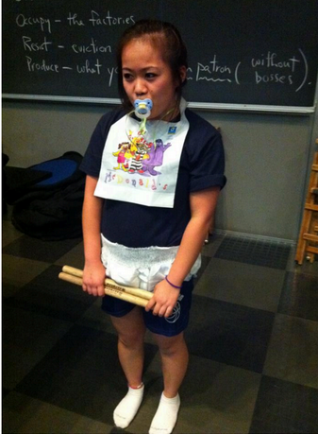

P.S. I suck at haikus LOL Tabi 2.0???
May the Odds Be Ever in Your Favor,
- Devin “Swag Man” Tani

To: RANDOM KYODO GIRL
Dear, Sweet Kyodo Girl
PREPARE TO GET SO DESTROYED.
Sorry, Not Sorry.
<3 Vicky Phan 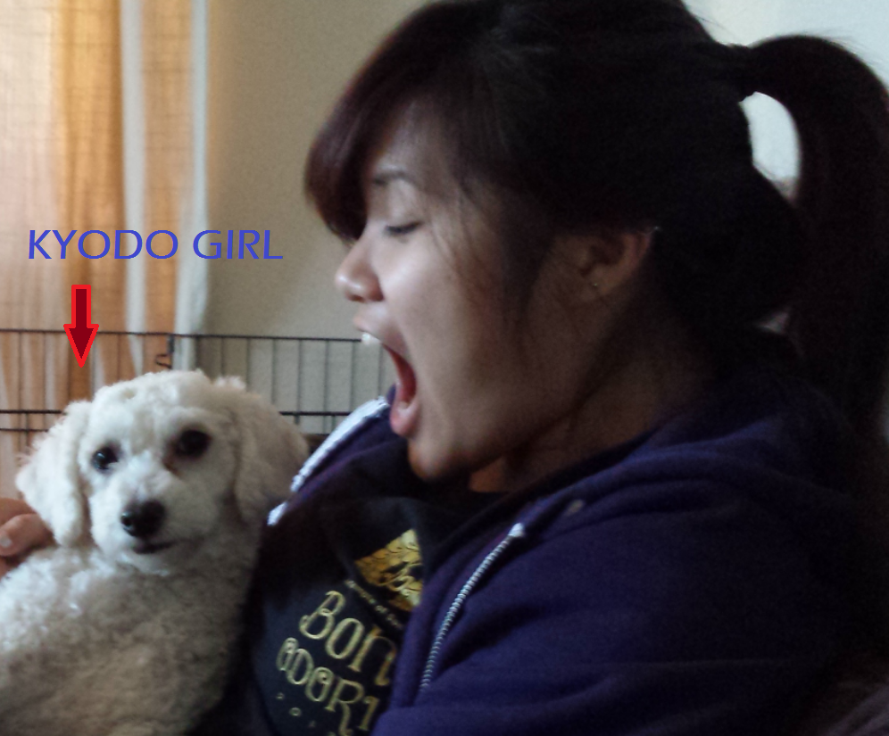
Random Kyodo Girl
Let Us Be The Best of Friends
But Today, We Fight!
- Megan Matsumoto

To: SAMANTHA and KELVIN 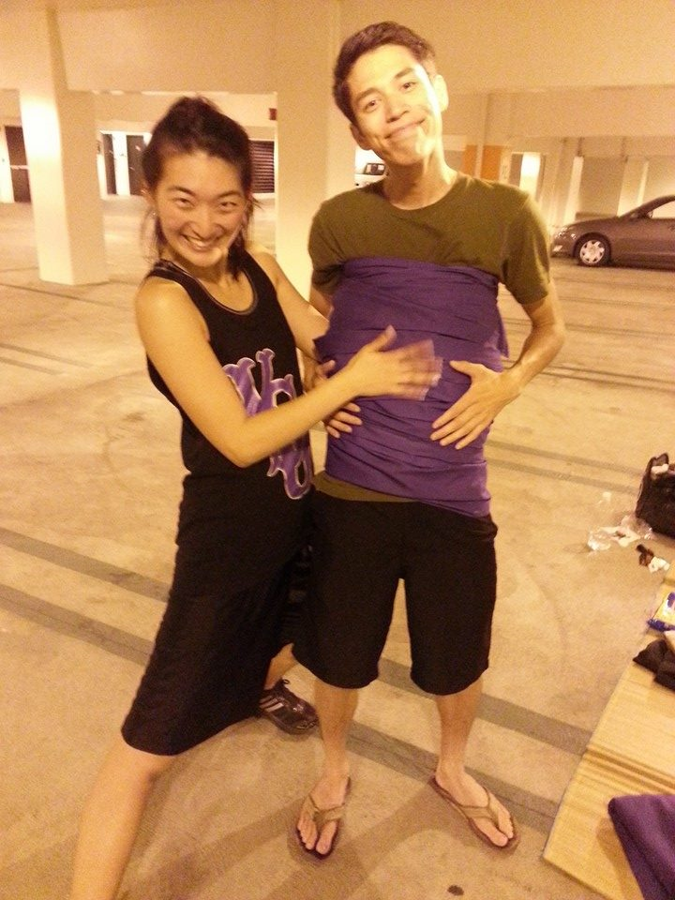
Jab Jab Uppercut
We’re Gonna Battle Like What
DON KRA KRA you’re DONe.
- Jen and Ryley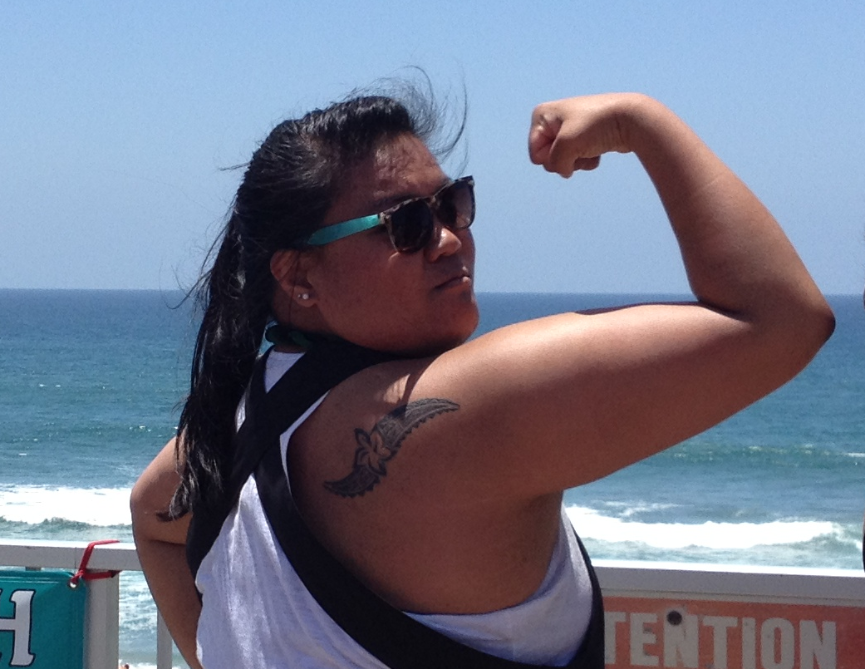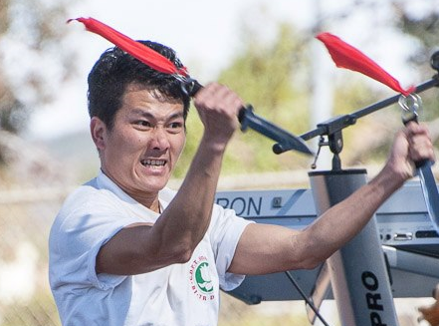

To: MIKE and DAN
We May Look Little
But After You See Us Play
We’ll Make YOU Look small.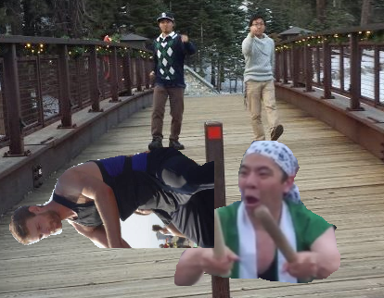
- Jimmy and Jordan

Dated this 14 of January, 2014,
Diana Wu (on behalf of Naruwan Taiko): 